Nama : Tomy Ilham H

NIM : L200150063

Kelas : B

AlgoritmadanStruktur data

Perbandingan Sequential search,Sequential search(Sorting),Binary search,analisis Binary search

Sequential search

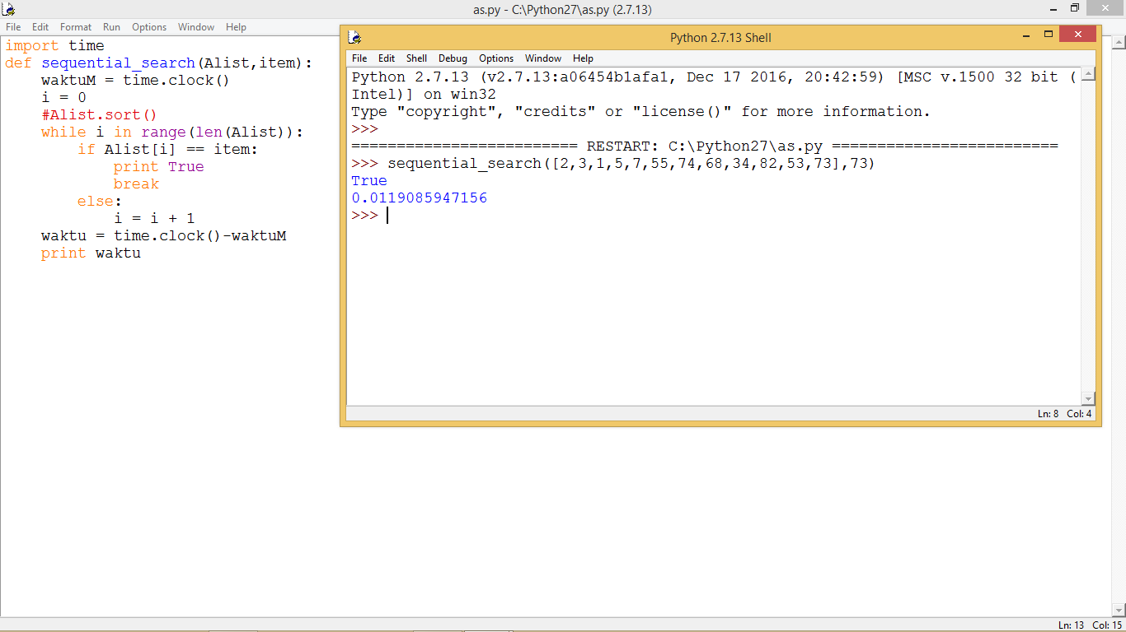

Sequential search (sorting)

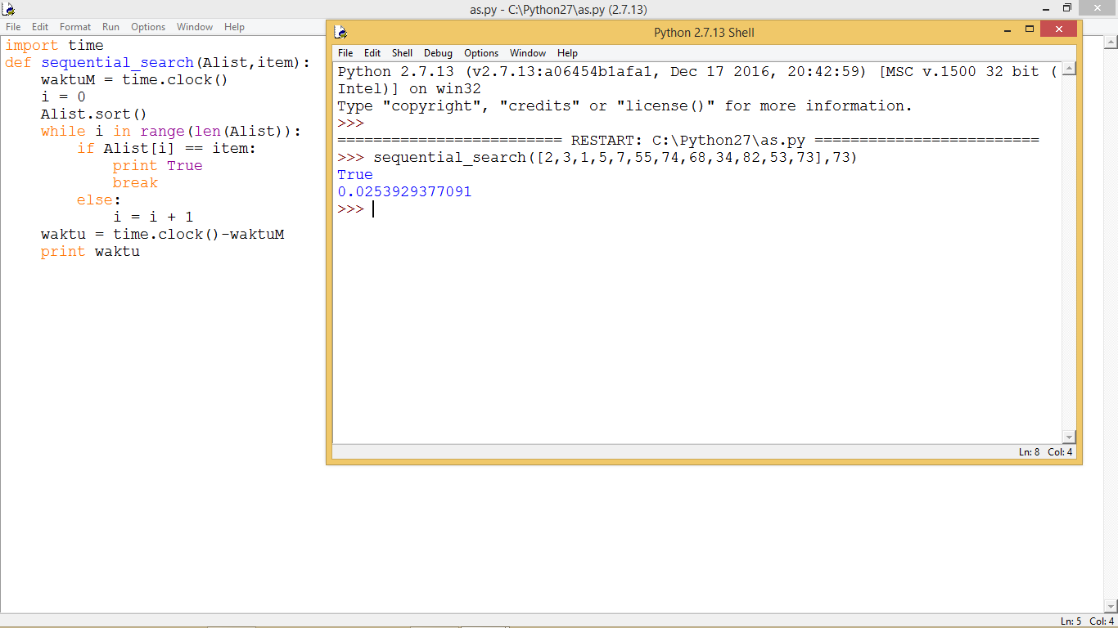

Binary searching

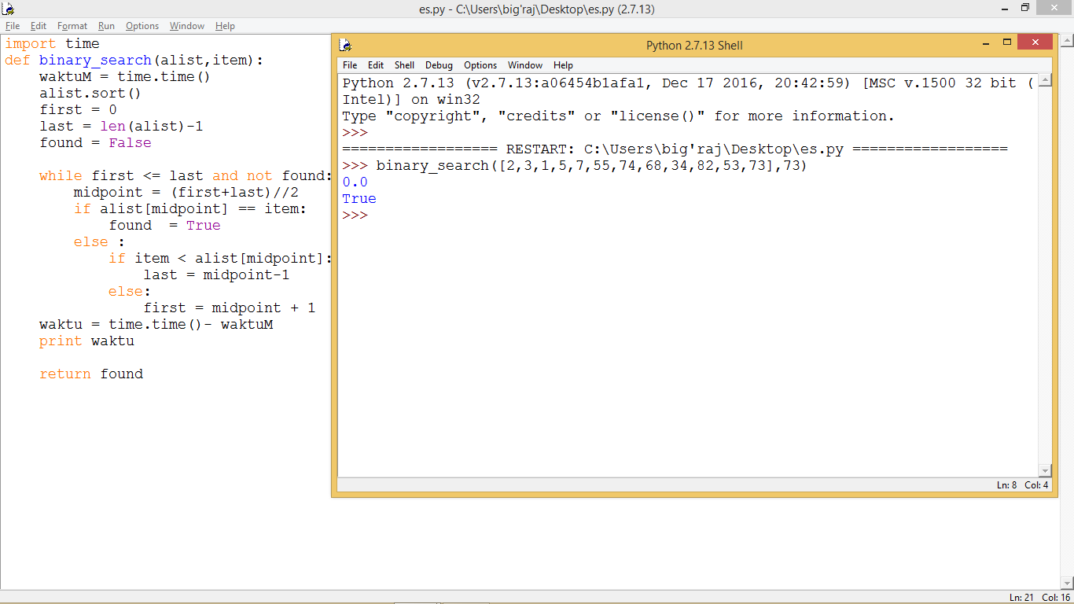

Analisis binary search